Email header:

Get the right flow meter with this selection-questions list

Email content:

Get your flow measurements right by selecting and installing your flow meter properly. Collect all the information your need for your flow meter selection and for selecting the right installation point. Here is a short list:
- What is the purpose of your measurement?
- What type of gas do you want to measure?
- What is the expected gas flow (range)?
- What is the gas pressure (range)?
- What is the gas temperature (range)?
- Is the media dry or saturated?
- What is the pipe diameter?
- How do plan to use the meter? Permanently or as audit tool.
For the complete questions list, click here to go to our website.

VPFlowScope flow meters for compressed air and industrial gases:

VPFlowScope DP | VPFlowScope M
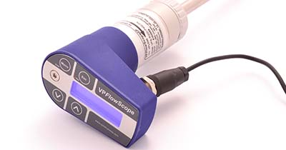 | 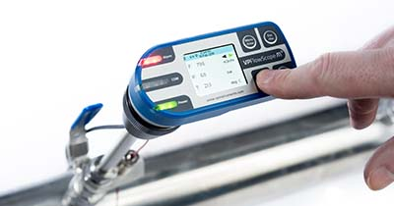
The patented VPFlowScope® DP enables you to take measurements in the discharge pipe of a compressor under 100% saturated conditions. Combine the VPFlowScope DP with a power meter and measure compressor efficiency.  Learn more, click here. | The VPFlowScope® M is the next step in gas measurement. Unlike traditional flow meters, the VPFlowScope M consists of a Transmitter and the patented VPSensorCartridge®, which reduces recalibration to a simple exchange.  Learn more, click here.

VPFlowScope In-line | VPFlowScope Probe
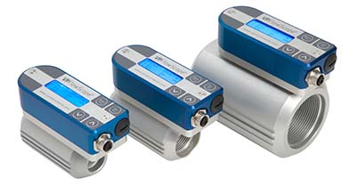 | 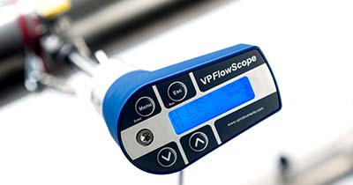
The VPFlowScope® In-line is the ideal flow meter for point of use consumption measurement. It is perfect for smaller diameters where it produces all the data you need to optimize your compressed air consumption.  Learn more, click here. | The VPFlowScope® Probe is the measurement tool for dry compressed air and other technical gases like nitrogen, carbon dioxide and argon. It is available for 16 bar and 35 bar compressed air applications.  Learn more, click here.

With kind regards,

